Rotating Equipment Quality Planner
User guide for first-time users
Istec Training · Quality Control of Rotating Equipment · version 1.6 · September 2026

This guide takes you through the Quality Planner from the first click to a filed, exported quality plan. No computer skills beyond using a web browser and Excel are assumed. Words in bold are the exact names you see on the screen.

1. What the app does
The Quality Planner turns the Rotating Equipment Maintenance and Inspection Requirement Register into a quality plan for one machine. You tell it which machine you mean, confirm how critical the machine is, and it writes the plan for you:
- the standards and guidelines that govern the machine,
- the maintenance requirements,
- the inspection and condition-monitoring requirements,
- the intervals for the criticality class you chose, placed on a standard frequency scale,
- the quality and acceptance criteria,
- the hold points (when work must stop for an inspector) and who is responsible,
- extra requirements for special services such as oxygen, sour gas, hydrogen, slurry or cryogenic duty.
Every plan you make is filed in a register table. The register can be edited on screen, exported to Excel, and read back from Excel. In Chrome or Edge the app can also save straight into an Excel workbook that lives next to it, for example on a USB stick.
Tip The register values are typical industry practice and are a starting point only. Always check intervals and acceptance values against your site specifications and the OEM manuals before you use a plan.

2. What you need
- A web browser. Google Chrome or Microsoft Edge give the full experience, including saving straight into the Excel file. Firefox and Safari work too, but you will use Import and Export instead.
- The app file. "Rotating Equipment Quality Planner.html". It is a single file. Nothing is installed and no internet connection is needed.
- The register workbook. "Rotating Equipment Quality Plans.xlsx", kept in the same folder as the app. This is where your plans are saved.
If you were given the online version instead (a claude.ai link), skip section 4: there the register is shared with your colleagues automatically and Excel export is offered through a download prompt.

3. Open the app
1. Copy the whole folder to your computer or USB stick. Keep the app and the workbook together.
2. On Windows, double-click Start Quality Planner.cmd. On any computer you can also double-click the .html file, or right-click it and choose Open with → Google Chrome.
3. The app opens with an example machine already loaded, so you can see what a finished plan looks like before you start.
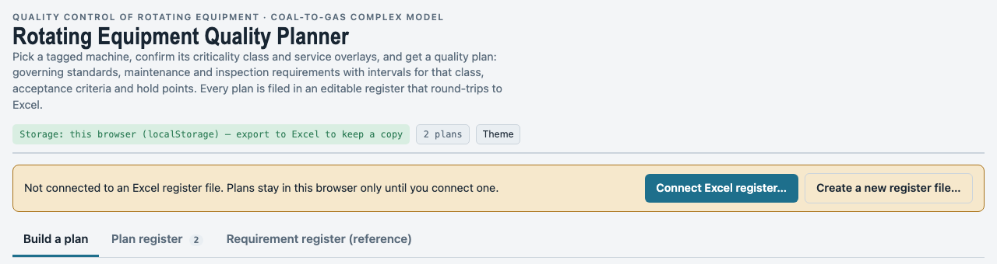
Figure 1 · The top of the app: the storage pill, the amber "connect" bar and the three tabs.
The screen has three tabs:
- Build a plan is where you describe a machine and generate its plan.
- Plan register is the table of every plan you have filed.
- Requirement register (reference) shows the source data: the register itself, the criticality matrix, the frequency bands, the service overlays and the standards list. You do not edit anything here.
The green or amber pill at the top right always tells you where your plans are being saved.

4. Connect the Excel register file (Chrome and Edge)
Until you connect the workbook, plans are kept inside the browser on this computer only. Connecting takes a few seconds and only needs doing once per session.
Figure 2 · The amber bar before the workbook is connected.
1. Click Connect Excel register… in the amber bar.
2. Choose "Rotating Equipment Quality Plans.xlsx" from the app folder and click Open.
3. Allow the browser to view and edit the file when it asks. The bar turns green and shows the file name.
4. From now on every plan you file, edit or delete is written into the workbook within a second. The pill at the top right shows the time of the last save.
Next time you open the app, the bar offers Reconnect to Rotating Equipment Quality Plans.xlsx. Click it and allow access again. On a different computer, use Connect Excel register… and pick the file.
Tip Close the workbook in Excel before you file plans. If Excel has it open, the app cannot write to it. The app warns you, keeps the plans in the browser, and writes them the next time a save succeeds.

Starting a brand-new register? Click Create a new register file…, choose where to save it, and the app creates an empty workbook with the right sheets.

5. Build a plan
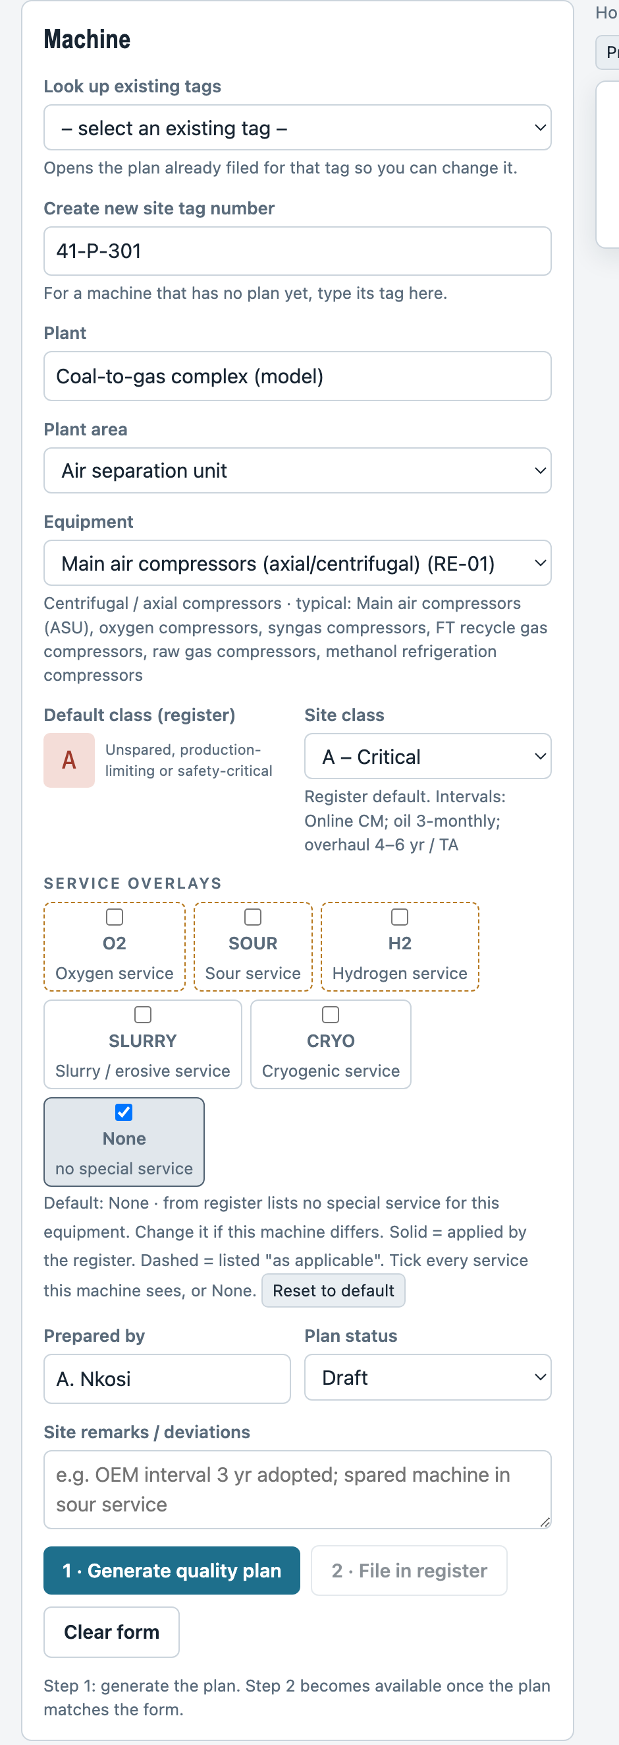
Figure 3 · The Machine form.
1. Look up existing tags / Create new site tag number. The form starts with two boxes. For a machine that has no plan yet, leave the top box alone and type the tag in the lower box, Create new site tag number, for example 41-P-301. For a machine that already has a plan, open the top list, Look up existing tags, and pick its tag: the app opens that plan, the lower box shows its tag, and filing again updates the same row instead of making a second one. Tags listed under "Used before, not in the register" only fill in the form, ready for you to generate and file. Click Clear form to go back to a blank form. Tags must be unique in the register (see section 9).
2. Plant. The site or unit. Type it once; it is remembered for next time.
3. Plant area. Pick the process area, for example Air separation unit. The last entry, Any equipment type (whole register), lets you choose from all 23 machine types when your machine does not appear under its area.
4. Equipment. Pick the machine. The grey note under the box shows the machine group and typical examples from the register.
5. Default class (register) and Site class. The coloured letter is the criticality class the register gives this machine type: A critical, B essential, C general. Next to it, choose the class your site actually assigns. It starts on the register default. The note under the box shows the intervals for the class you choose, so you can see the effect at once.
6. Service overlays. Tick every special service this machine sees, or tick None. This choice is compulsory: the app will not generate a plan until at least one box is ticked. The app proposes a default and says where it came from in the line under the boxes: first from a plan you filed earlier for the same plant, area and equipment type; otherwise from the register row together with the plant area and the equipment wording (a cryogenic LOX pump in the air separation unit starts as O2 and CRYO; a boiler feedwater pump starts as None). Change the ticks if your machine differs, and click Reset to default to go back. Ticking None clears the others. A solid box is one the register applies to that machine type; a dashed box is listed "as applicable". O2 oxygen, SOUR sour gas, H2 hydrogen, SLURRY erosive slurry, CRYO cryogenic.
7. Prepared by, Plan status and Site remarks. Your name, Draft / Reviewed / Approved, and any site deviations, for example "OEM interval of 3 years adopted".
8. Click 1 · Generate quality plan. The plan appears on the right and the button 2 · File in register becomes active. The two steps are enforced: File is only available for a plan that matches the form. If you change anything in the form after generating, the preview is greyed with the message "Form changed – generate the plan again" and File is disabled until you generate once more. Nothing is filed until you press step 2.
Tip Keyboard shortcut: press Ctrl+Enter (Cmd+Enter on a Mac) to generate the plan from anywhere in the form.

6. Read the quality plan
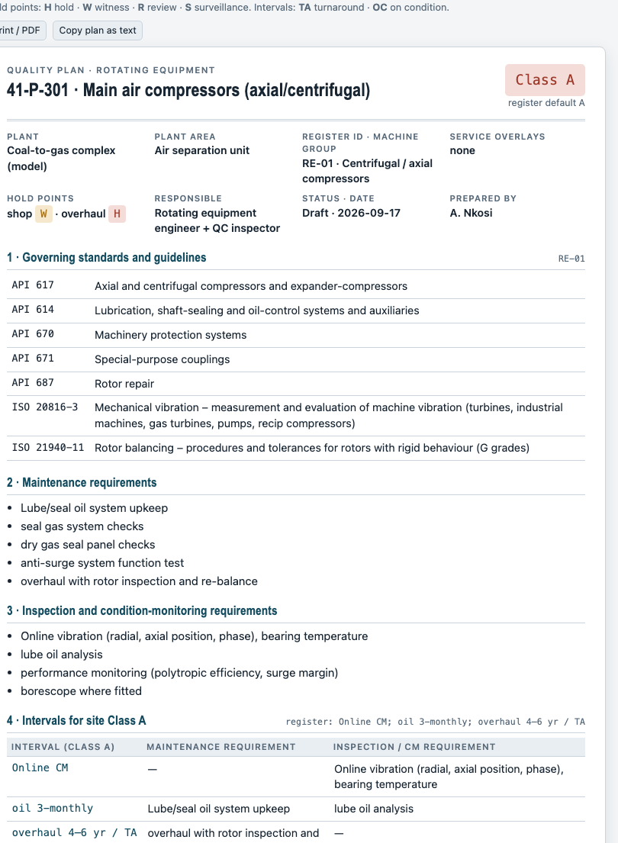
Figure 4 · A generated plan. The class chip at the top right shows the site class and whether it differs from the register default.
The plan is laid out like an inspection and test plan:
Section | What it contains
Header | Tag, machine, plant, area, register ID, class, overlays, hold points, responsible discipline, status and date.
1 Governing standards | Each standard with its title, plus any standards added by the overlays you ticked.
2 Maintenance requirements | The maintenance tasks for this machine type.
3 Inspection and CM requirements | The inspection and condition-monitoring tasks.
4 Intervals for the site class | Each interval from the register for your class, matched to the maintenance or inspection task it belongs to. If the register has no interval for the class you chose, the plan says so and shows the intervals of the other classes instead.
5 Frequency schedule | Every task of the plan on the standard frequency scale, most frequent first (see section 7).
6 Quality and acceptance criteria | The values the machine must meet: vibration, balance grade, clearances, test results.
7 Service overlay requirements | Only when overlays are ticked: the extra standards, tasks, intervals and acceptance criteria for that service, with its hold point.
QC depth for the class | From the criticality matrix: how deep procurement QC, materials verification, installation QC, condition monitoring, overhauls, spares, repairs, documentation and personnel must go for this class.
Related register items | Cross-cutting items applied with every plan: installation and alignment, couplings, machinery protection (Class A and B), lube and seal oil consoles (where fitted), severe-service materials and NDT, and the management system.
Sign-off lines | Prepared, Reviewed, Approved.

Hold-point codes: H hold (work stops until the inspector releases it), W witness (inspector notified; work may proceed if absent after agreed notice), R review (documents reviewed), S surveillance (random monitoring). Interval codes: TA turnaround, OC on condition.
Two buttons sit above the plan: Print / PDF prints only the plan (use "Save as PDF" in the print dialog to make a file), and Copy plan as text puts a plain-text version on the clipboard for pasting into an email or a work order.

7. Task frequencies: one machine, many intervals
A machine never has a single frequency. A compressor might need online vibration monitoring all the time, an oil sample every three months and an overhaul every four to six years. The app handles this at two levels.
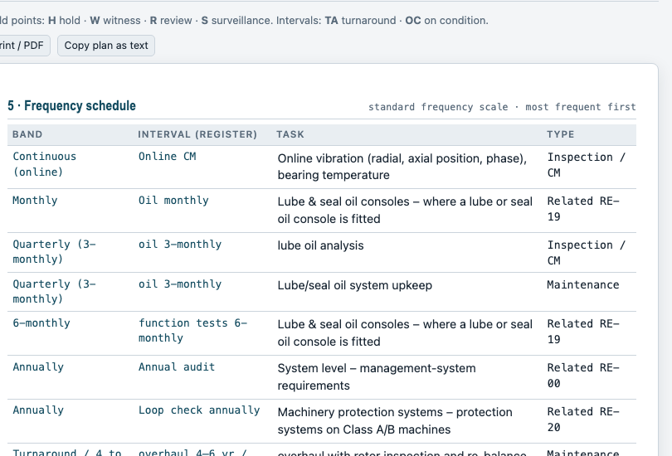
Figure 5 · The frequency schedule in a plan: one row per task, most frequent first.
- In the plan, section 5 lists every task with its interval from the register and its frequency band, sorted from the most frequent to the least. A footnote names the most frequent task and the bands present.
- In the plan register, each plan has four summary columns: Most frequent task, Frequency rank (1 = most frequent), Frequency bands present, and Scheduled tasks. Click a column heading to sort the register by it; click again to reverse the order. Sorting by Frequency rank puts the machines with the most demanding routine at the top.
- In Excel, the workbook has a Task schedule sheet with one row per task across all plans: tag, equipment, class, task type, task, interval, frequency band, rank, approximate period in days, basis and source. Filter arrows are already on the header row, so you can show, for example, only weekly tasks, or sort the whole plant by rank. The app rewrites this sheet every time it saves; it is not read back, so edit plans in the app or in the Quality plans sheet, not here.
The standard frequency scale is:
Rank | Frequency band | Approx. period | Register wording it covers
1 | Continuous (online) | — | online CM
2 | Hourly or more often | ~1 hour | hourly
3 | Per shift | 8 hours | per shift
4 | Daily | 1 day | daily
5 | Weekly | 7 days | weekly run, weekly visual
6 | Monthly | 30 days | monthly, route CM monthly
7 | Quarterly (3-monthly) | 91 days | quarterly, 3-monthly, 3–6 monthly
8 | 6-monthly | 182 days | 6-monthly, 6–12 monthly
9 | Annually | 365 days | annually, annual audit, 12 monthly, 8 000 EOH
10 | 2 to 3 yearly | ~2.5 years | biennial, 3 yr, 24 000 EOH
11 | Turnaround / 4 to 6 yearly | ~5 years | 4–6 yr / TA, at TA, 5 yr, 48 000 EOH
12 | Longer than 6 yearly | 8 years | 6–8 yr
13 | At specified events | — | at every opening, at installation and after each disturbance, at repair, at overhaul, per ITP
14 | On condition | — | OC, overhaul OC
15 | Not defined | — | n/a, or wording the app cannot read

Two rules to know: a range such as "3–6 monthly" is placed at its shorter end (quarterly), because that is the interval you must plan for; and equivalent operating hours (EOH) on gas turbines are converted at 8 000 hours per year of continuous duty. Where the register says "n/a" for your class, the task is placed in Not defined and the plan asks you to confirm the interval with the site.
Tip Want the whole plant's routine in one list? Export to Excel, open the Task schedule sheet, and sort by Frequency rank. Tasks at rank 1 to 5 are the daily and weekly routine; 6 to 9 are the monthly-to-annual programme; 10 to 12 are turnaround work; 13 to 15 are event-driven or on condition.

8. File the plan in the register
1. Click 2 · File in register (active only after step 1 with no later changes to the form). The plan becomes a row in the Plan register tab. The count on the tab goes up by one and the pill confirms the save.
2. To change a filed plan, open it from the register (section 10), edit the form, generate again and click File in register. The same row is updated; no second row is made.
3. Click Clear form to start a new machine.

9. One tag, one plan
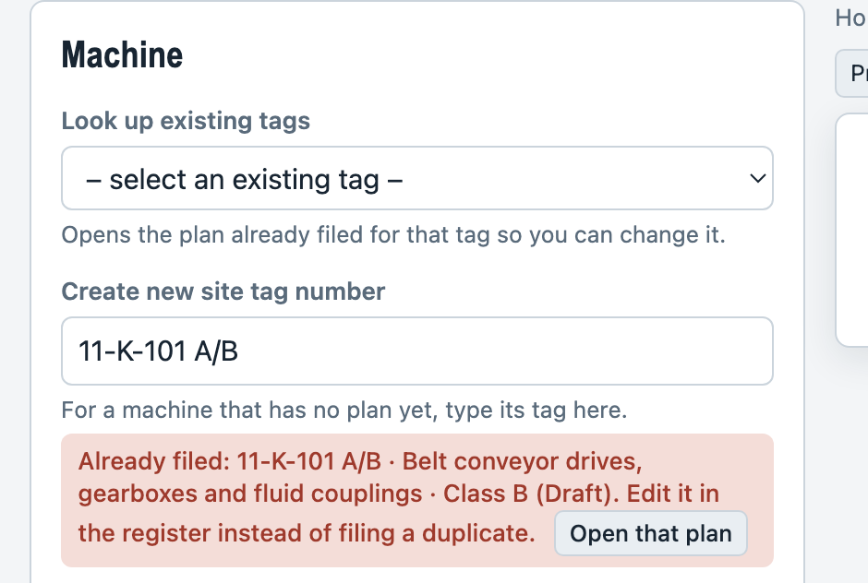
Figure 6 · The warning shown when a tag is already in the register.
A site tag can only be filed once. Every tag already in the register is in the Look up existing tags list, so pick it there rather than typing it again. If you do type a tag that is already in the register, a red box appears under the field naming the existing plan. If you try to file anyway, the app refuses and explains:
"Site tag … is already in the register. To change that plan, open it from the Plan register tab and edit it there. To file a second plan for the same machine, use a different tag (for example add a suffix)."
Click Open that plan in the red box to jump straight to the existing plan. Capital letters and extra spaces do not matter: 11-k-101 and 11-K-101 are the same tag.

10. Work in the plan register
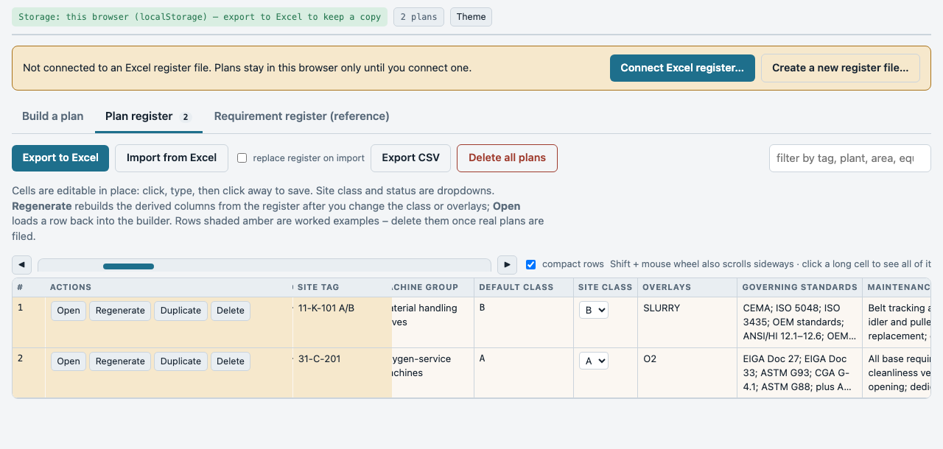
Figure 7 · The Plan register tab.
The register is a wide table; scroll sideways to see all the columns. The first rows may be amber: those are worked examples that came with the app. Delete them once you have real plans.
- Scroll sideways: drag the blue scrollbar strip above the table, click the ◀ ▶ buttons, or hold Shift and turn the mouse wheel. The row number, the action buttons and the site tag stay pinned on the left while you scroll. The table itself is limited in height, so the bottom scrollbar is always in view.
- Compact rows: ticked by default, long cells show three lines. Click in a cell to see and edit all of it; untick the box to show everything at once.
- Sort: click any column heading. Click again to reverse. The arrow shows the current sort.
- Edit a cell: click in it, type, then click somewhere else. The change is saved at once. Site class and Status are drop-down lists.
- Open: loads the row back into the builder so you can change it properly and re-file it.
- Regenerate: rebuilds all the derived columns (standards, requirements, intervals, frequencies and so on) from the register. Use it after you change the site class or overlays in the table.
- Duplicate: makes a copy of the row with "(copy)" added to the tag. Rename the tag before you use it.
- Delete: removes the row after you confirm.
- Filter box: type part of a tag, plant, area, machine name or frequency band to show only matching rows.
- Delete all plans: empties the register after you confirm. Export first if you want a copy.

11. Export to Excel and import from Excel
If you connected the workbook in section 4 you do not need to export: the workbook is always up to date. Export and import are for sharing, for backups, and for browsers that cannot connect a file.
1. Export to Excel saves a workbook with five sheets: Quality plans (one row per plan), Task schedule (one row per task, with frequency band and rank), Frequency bands (the scale), Tags (the machines you have used, for auto-fill) and Register (source). Filter arrows are set on the plan and schedule sheets. Export CSV saves the plans only, as a plain text table.
2. Import from Excel reads a workbook or CSV in the same layout. Rows are added to the register. Rows whose tag is already in the register are skipped and listed, so nothing is overwritten by accident.
3. Tick replace register on import before importing if the file should become the whole register, replacing what is there now.
Tip The app finds columns by their header names, so keep the header row of the "Quality plans" sheet exactly as exported. You may add your own sheets to the workbook; the app keeps them.

12. Look up the source data
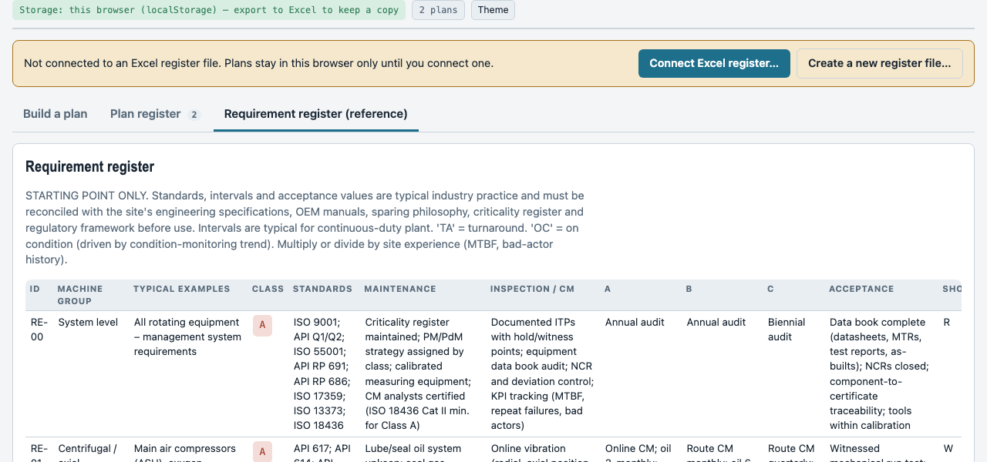
Figure 8 · The reference tab shows the register the plans are built from.
The Requirement register (reference) tab shows the full register row for every machine type, the criticality matrix that defines classes A, B and C, the frequency bands, the five service overlays, and the list of standards with their titles. Use it when a delegate or colleague asks where a requirement in a plan comes from.

13. If something goes wrong
What you see | What to do
The amber bar says the app is not connected | Click Connect Excel register… and choose the workbook (Chrome or Edge only). In other browsers use Import and Export.
"Could not write the register file" | The workbook is open in Excel or the USB stick is write-protected. Close Excel or free the stick; the app retries at the next change. Your plans are kept in the browser meanwhile.
"Site tag … is already in the register" | That machine already has a plan. Open it from the register and edit it, or use a different tag.
"Choose the service overlays … or tick None" | The overlay choice is compulsory. Tick the services that apply, or None, then generate again.
File in register is greyed out | Press 1 · Generate quality plan first. If you changed the form after generating, generate again; the plan must match the form before it can be filed.
"No interval defined for Class …" in the plan | The register only gives intervals for some classes on that machine type. The plan lists the other classes' intervals; confirm the interval with the site specification and write it in Site remarks.
A task shows the band "Not defined" | The register wording could not be read as a frequency. Decide the interval with the site and note it in Site remarks.
Import says columns were not found | The file is not in the app's layout. Export a file from the app to see the expected headers and match them.
Plans are missing on another computer | Browser storage does not travel. Connect the workbook on the USB stick, or import the exported Excel file.
Excel export button does nothing | Your browser blocked the download. Allow downloads for the page, or use Export CSV.

14. Glossary
Term | Meaning
Class A / B / C | Criticality class. A critical (unspared, production-limiting or safety-critical); B essential (spared but in severe service); C general (spared utility duty).
Default class | The class the register gives a machine type. The site class is the class your site assigns to the actual machine.
Frequency band / rank | The standard scale in section 7. Rank 1 is the most frequent.
Hold point (H / W / R / S) | Hold, Witness, Review, Surveillance: how closely QC controls a step.
Service overlay | Extra requirements for oxygen (O2), sour (SOUR), hydrogen (H2), slurry (SLURRY) or cryogenic (CRYO) duty.
TA / OC / EOH | Turnaround / on condition / equivalent operating hours, used in intervals.
Register ID (RE-xx) | The row of the requirement register that a machine type belongs to.
ITP | Inspection and test plan: the document a quality plan feeds.
CM | Condition monitoring: vibration, temperature, oil analysis and performance trending.

Prepared with the Rotating Equipment Maintenance and Inspection Requirement Register, September 2026. Register values are illustrative and must be reconciled with site specifications before use.

